**Project Name: Image to Sketch Converter using python**

**Group members:**

Ankita Ashok Hulle (20UET302)

Sanika Nitin Kadam (20UET304)

Prajkta Neminath Patil (20UET307)

**Batch TY5**

In Python, an image is just a two-dimensional array of integers. So one can do a couple of matrix manipulations using various python modules in order to get some very interesting effects. In order to convert the normal image to a sketch, we will change its original values and assign its values similar to grey, in this way a sketch of the input image will be generated.

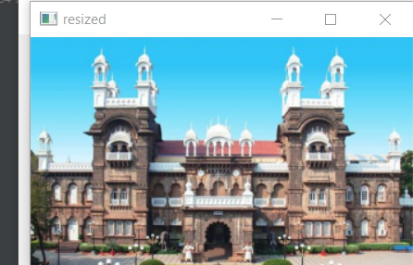

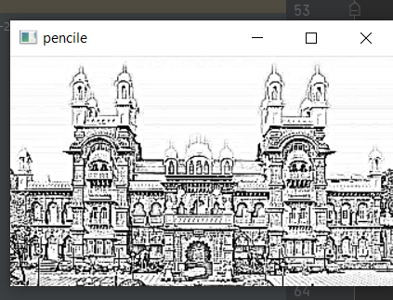

Working:

First we install the libraries required for project. Import all required modules (*Numpy*, *tkinter, OpenCV*). Open the message box and add any Image as input. Then check the shape of image. Convert image in black and white format using cvt colour function . Convert in image detection format using colour BGR2HSV function . Convert in inverse form. Convert in gaussian form using gaussian blur. Convert in gray format. Display sketch